Assignment – Git Basics (Day 1)

- What is DVCS and advantages of over CVCS
In a Distributed Version Control System, every developer has a complete copy of the repository, including its history, on their local computer.
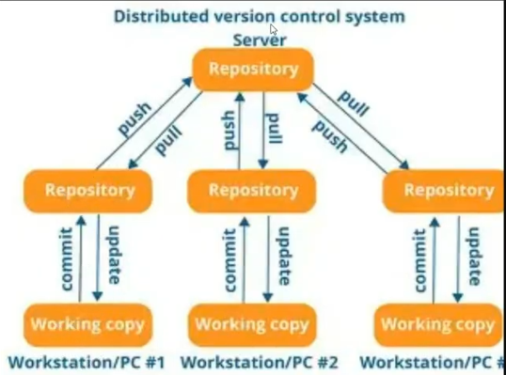
In a Centralized Version Control System, there is one central repository. Developers typically need to connect to it to perform version-control operations.
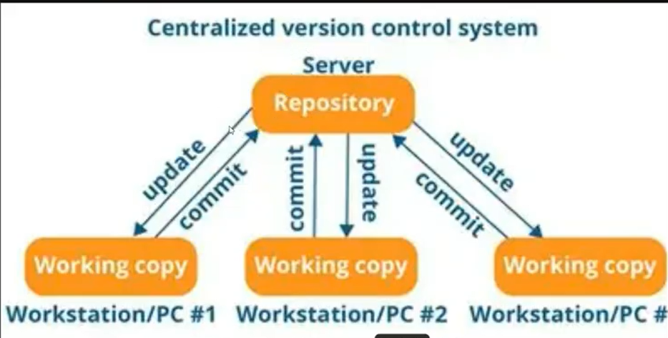

Advantages of DVCS over CVCS
DVCS | CVCS
Every developer has a full repository | Developers generally have a working copy, with the main history centralized
Can commit locally | Usually commits go to central server
Works offline for many operations | Server connection is commonly required
Faster local operations | Operations involving the server can be slower
No single central repository is required for local history | Central server is critical
Easy branching and merging | Branching/merging can be more cumbersome
Multiple copies provide redundancy | Central server failure can affect the team
Supports distributed workflows | Mainly follows a centralized workflow

- Explanation and examples of the following commands:

- git add is used to move changes from your working directory to the staging area.

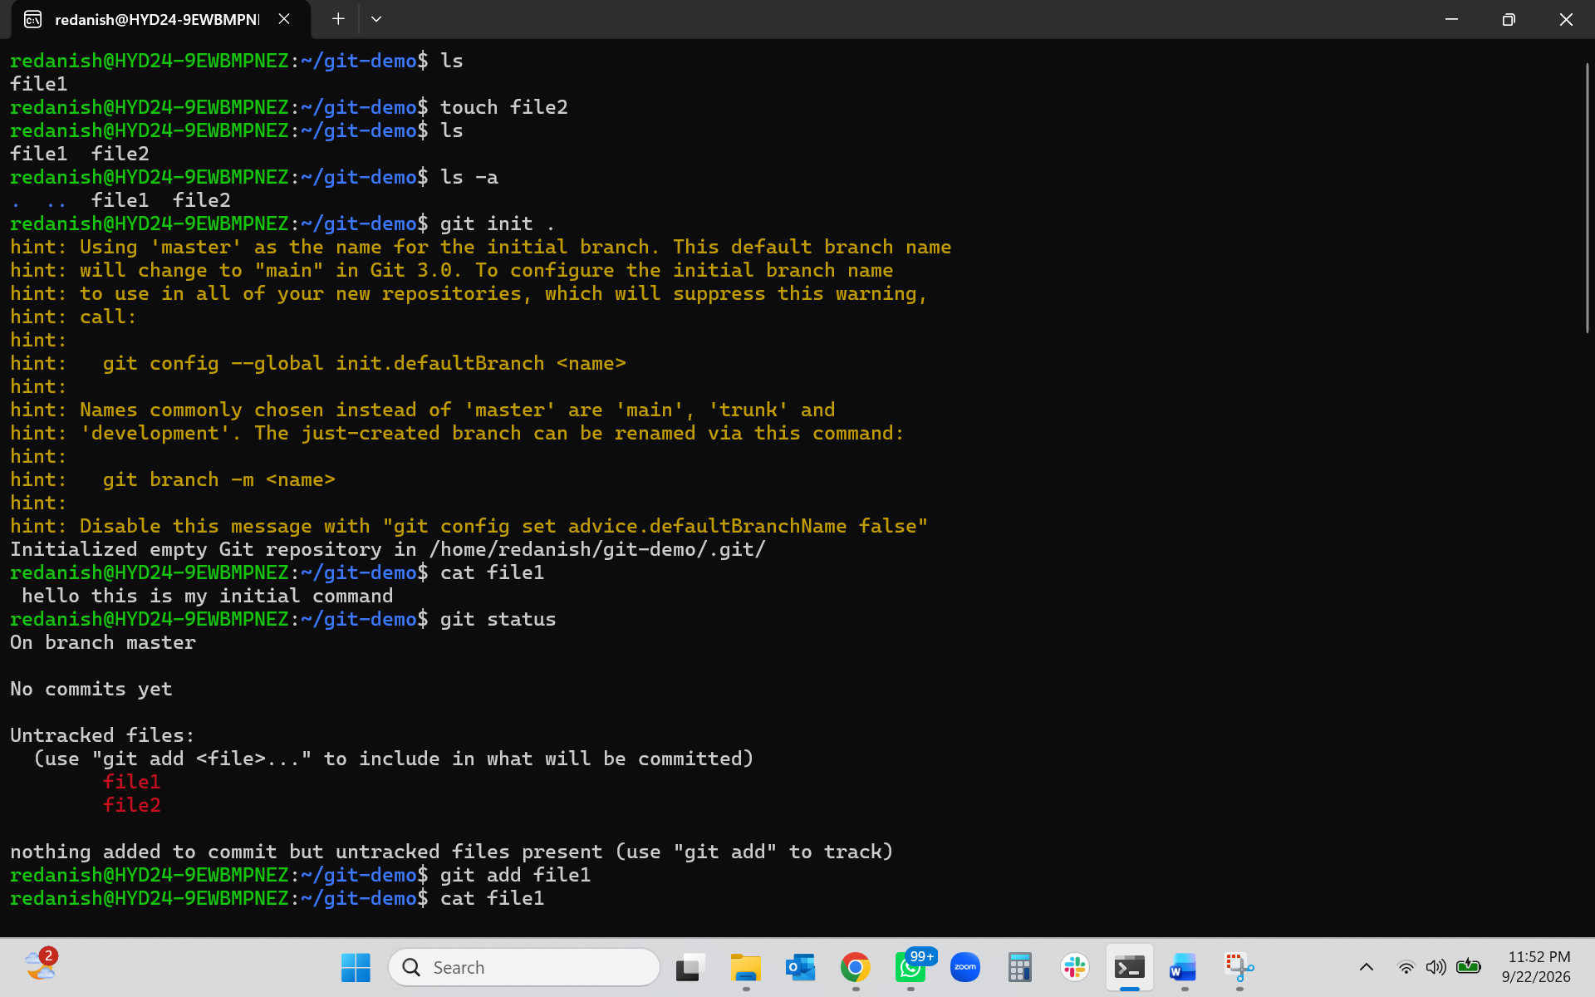
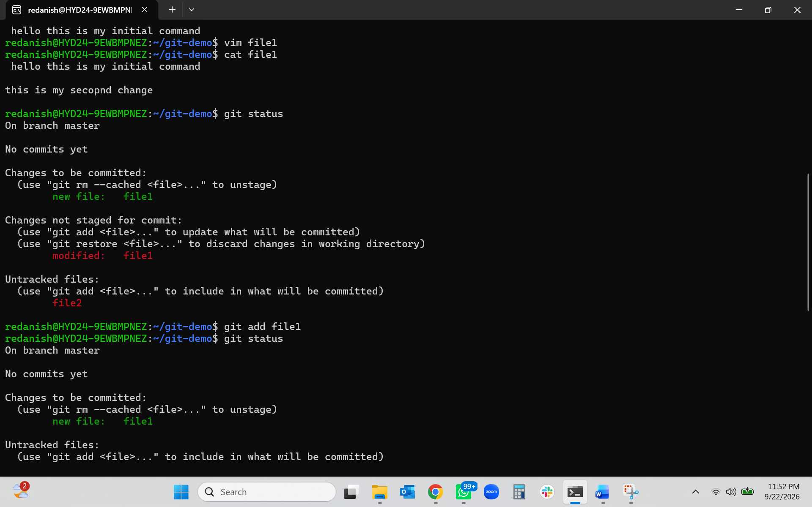
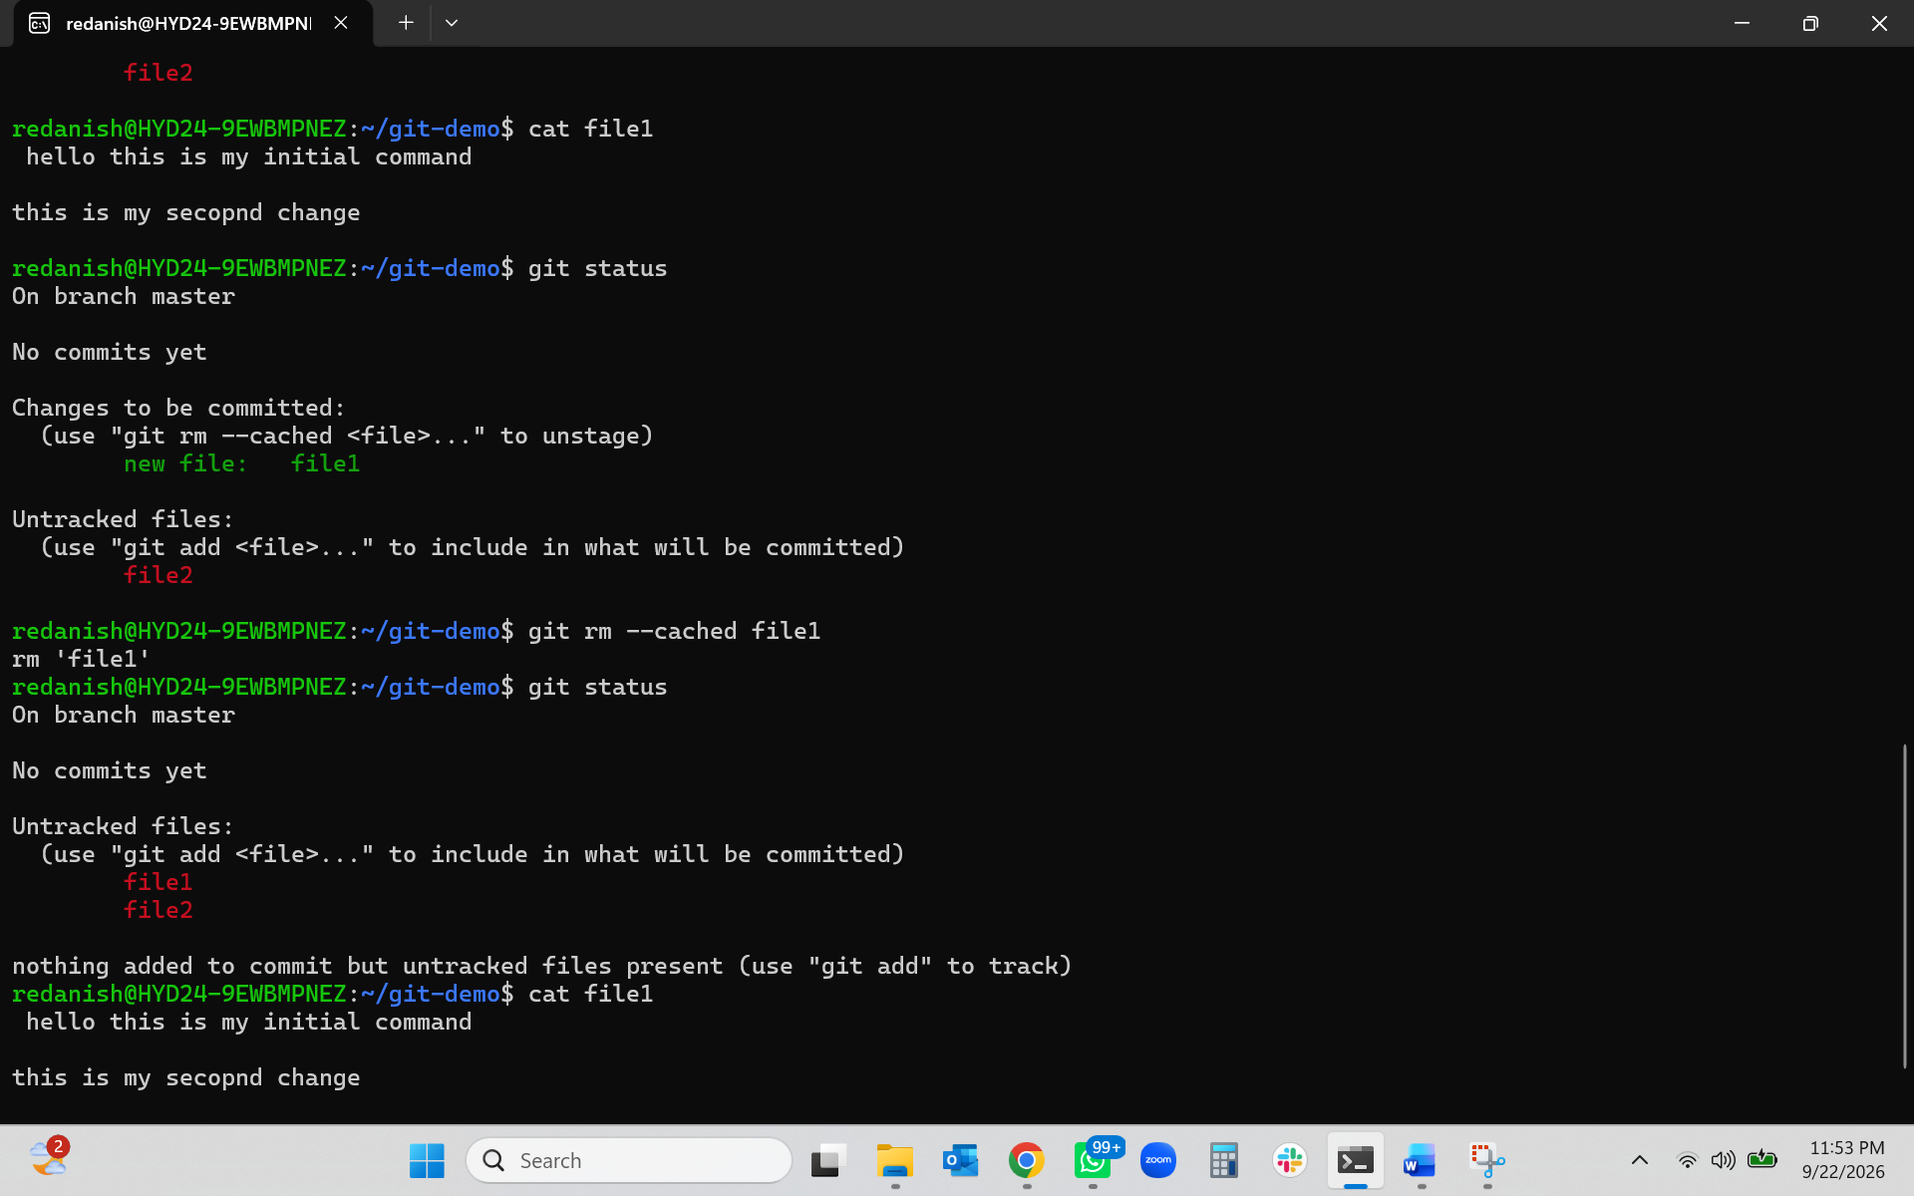

- git commit is used to save the changes that are currently in the staging area into your local Git repository.
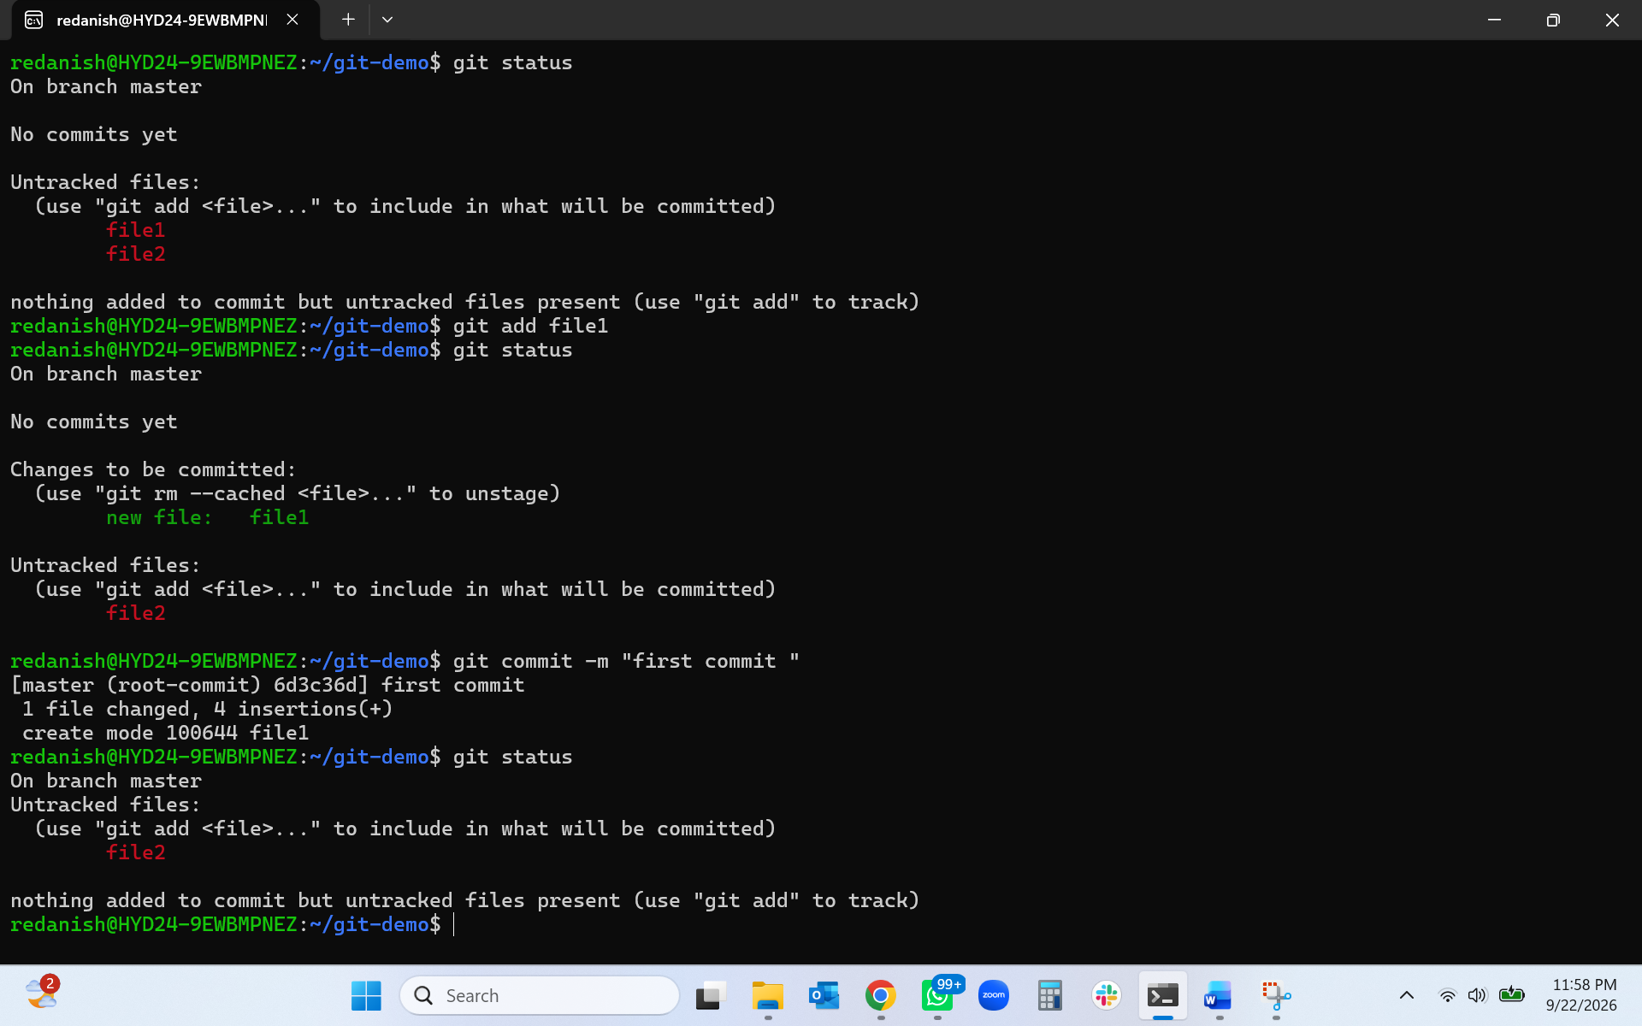

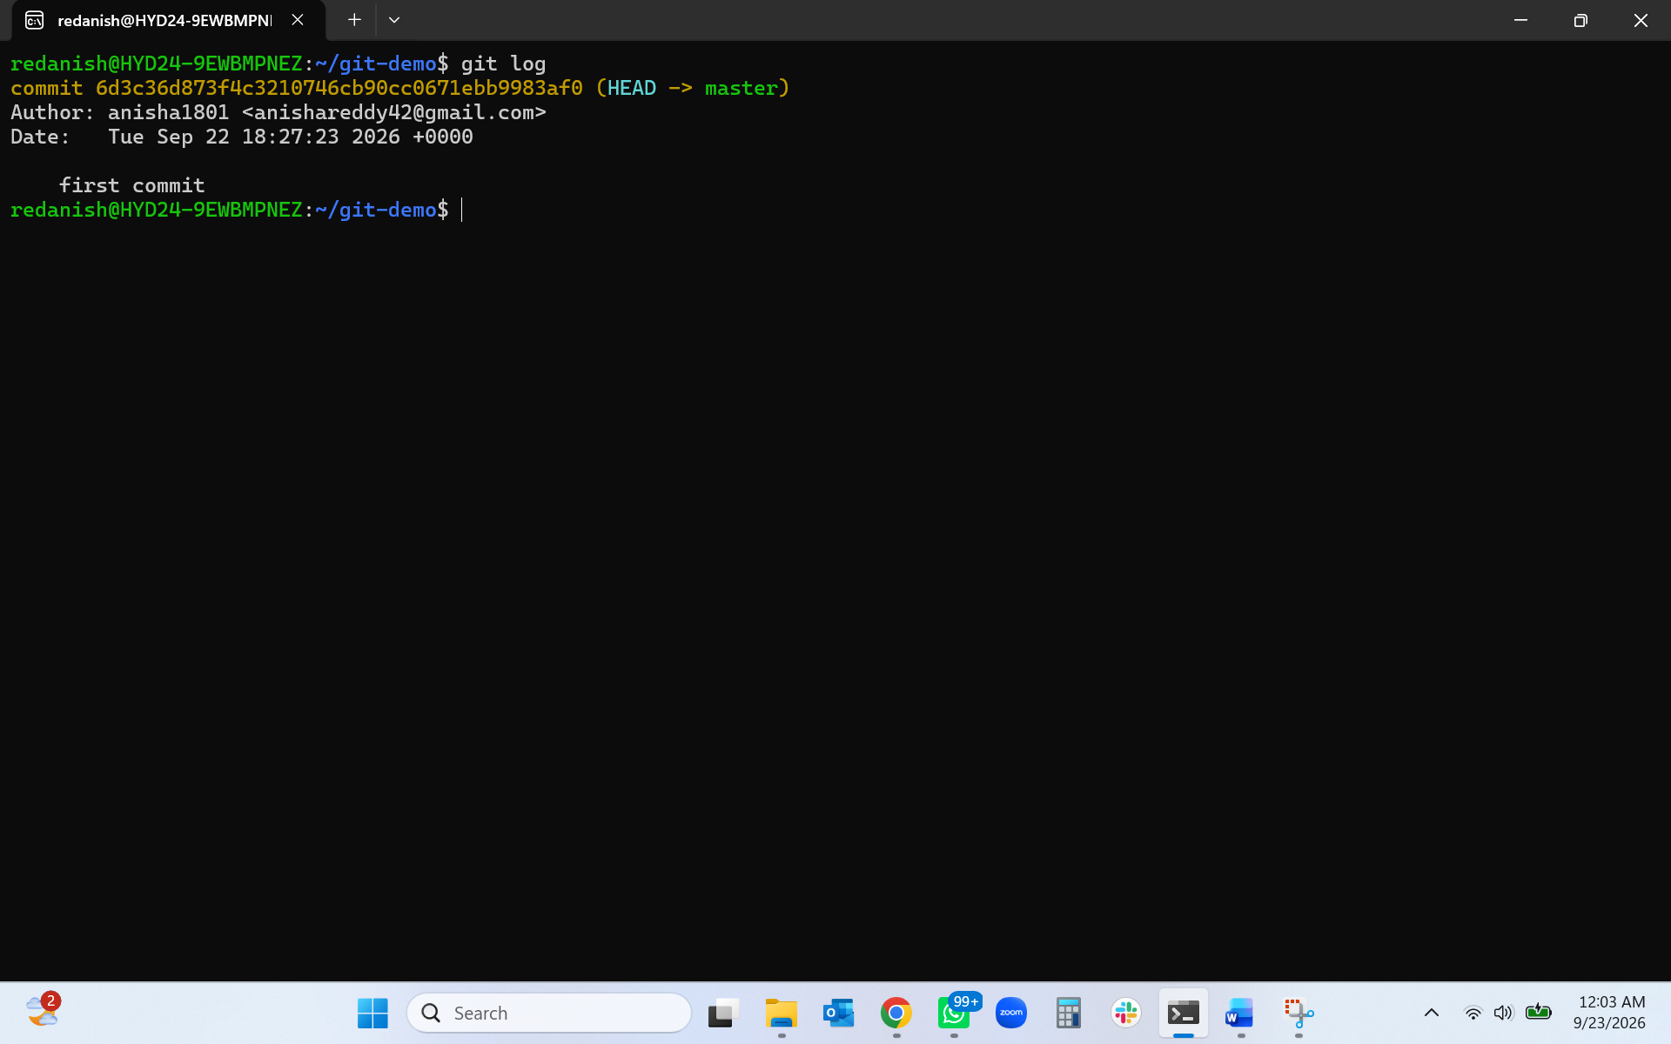
- git restore is used to undo changes in your working directory.
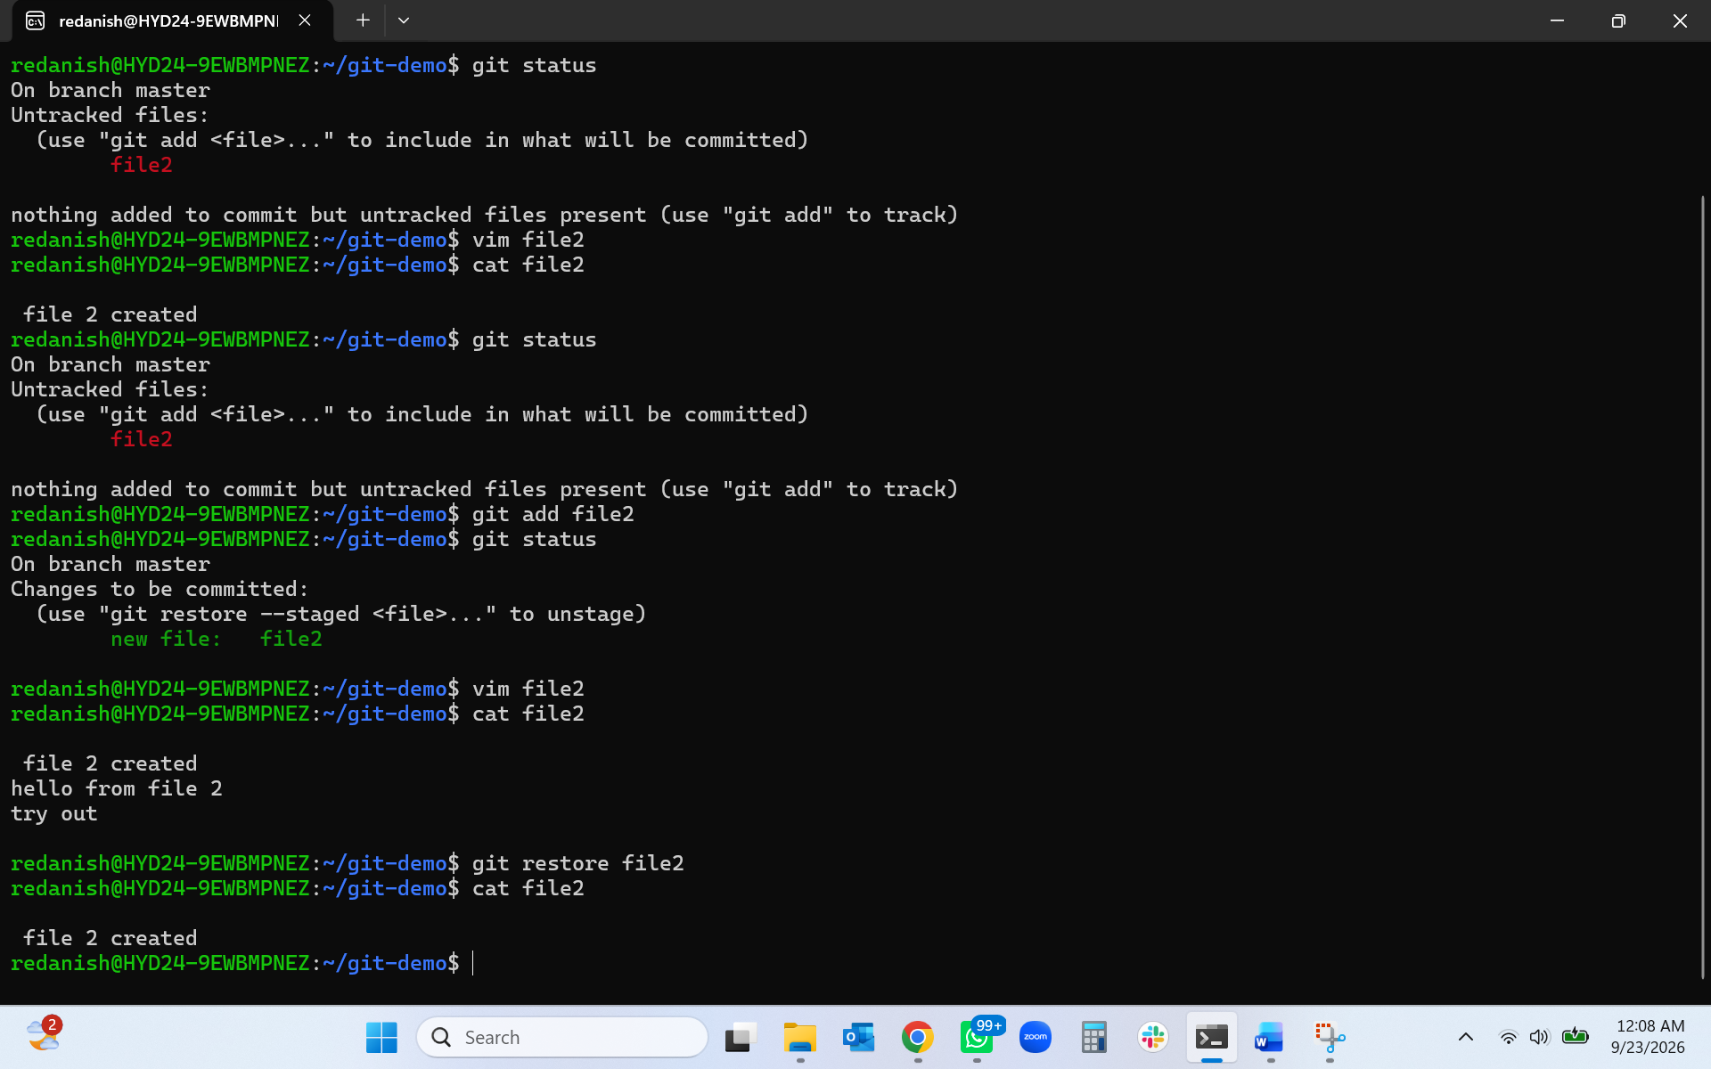
- git rm --cached is used to remove a file from Git's tracking/staging while keeping the actual file on your computer.
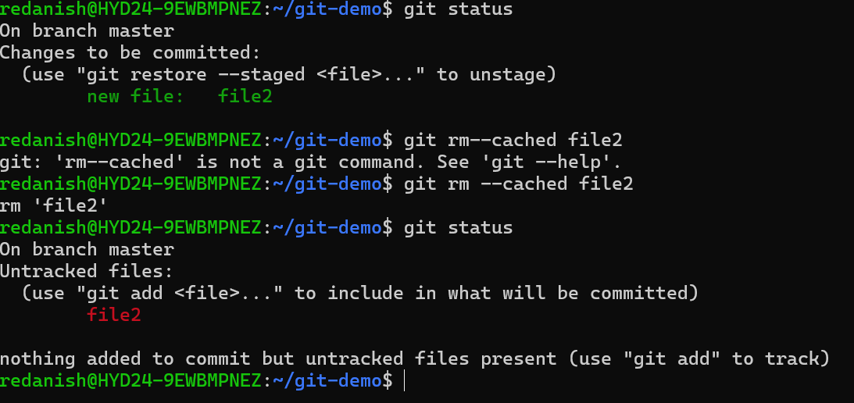

- git log is used to view the commit history of a Git repository.
- git log - -oneline - It shows your Git commit history in a short, one-line format.
